Parallel Workflows in LangGraph
CampusX • Agentic AI using LangGraph • Video 6
Duration: 59:29
Video: https://www.youtube.com/watch?v=O6ryuSpqdOw
Practice repository: https://github.com/campusx-official/langgraph-tutorials

Learning outcomes
Learn fan-out / fan-in execution, how parallel nodes update a shared state without collisions, when to use Annotated[..., operator.add], how to join parallel results, and why structured model output helps when several reviewers evaluate the same input.
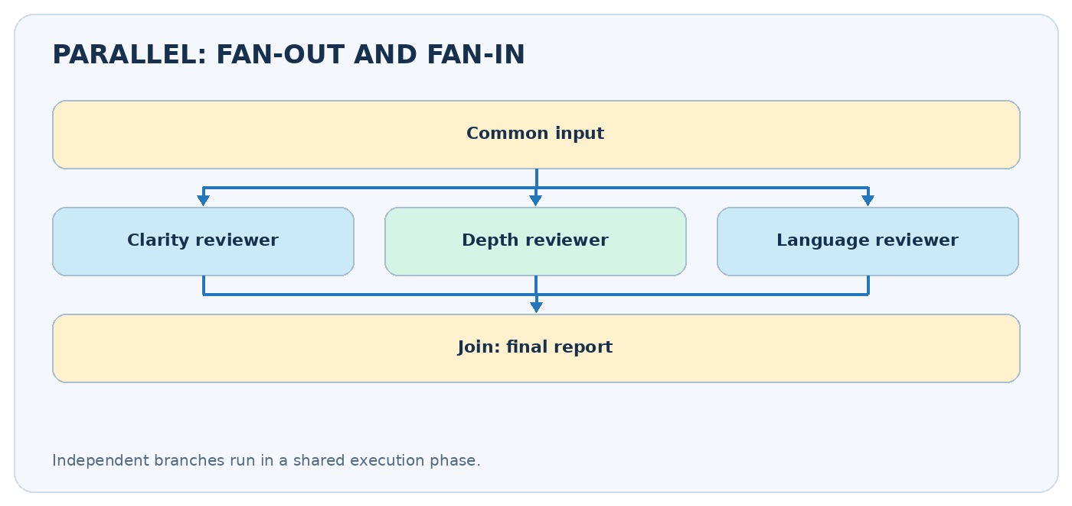
Parallel graph: one starting point, independent branches, one join

Video chapters — clickable timestamps
- 00:00 — Introduction
- 02:43 — Setup
- 07:15 — First workflow
- 26:11 — LLM workflow
- 36:55 — Additional workflow discussion

Example jump links
- Watch the cricket-statistics example from the first-workflow chapter.
- Watch the LLM-based discussion.

1. Parallelism vs sequencing
In a sequential graph, B waits for A and C waits for B. In a parallel graph, independent nodes B, C, and D can start from one common state snapshot, then a downstream node combines their results. Example: analyze an essay’s clarity, depth, and language at the same time, then calculate an overall report.
Remember: parallel is not the same as conditional. Parallel means several branches run. Conditional means choose a branch. Parallel branches can reduce wall-clock time for independent slow operations, but speed is limited by the slowest branch and the overhead of execution. It does not reduce the number of LLM calls or tokens consumed.

A simple analogy
Three cricket analysts calculate strike rate, boundary percentage, and balls per boundary from the same scorecard. All three can work independently. A fourth analyst creates the summary when their results are ready.

2. How LangGraph coordinates parallel nodes
LangGraph executes enabled nodes in logical supersteps. Nodes in the same superstep can receive the same pre-step state; their updates are then applied according to each state key’s reducer. A downstream join runs only once the relevant incoming branches have completed when the graph is wired as a join.
Term | Meaning
Fan-out | One upstream step starts several independent branches
Fan-in / join | A downstream node combines branch results
Partial update | A branch returns only keys it owns
Reducer | Function that merges multiple updates to one key
Default update | Replaces a key’s previous value when there is no reducer
A common design is START -> split -> [A, B, C] -> summarize -> END. The summarizer should read data after all three branches have supplied their outputs.

3. Example: cricket performance metrics
For a batsman with 80 runs, 50 balls, 8 fours and 3 sixes:
- Strike rate = runs / balls * 100 = 160.0.
- Boundary runs = 4*fours + 6*sixes = 50.
- Boundary percentage = boundary_runs / runs * 100 = 62.5%.
- Balls per boundary = balls / (fours + sixes) = approximately 4.55.
The three metrics are independent. None needs the other metric’s result.
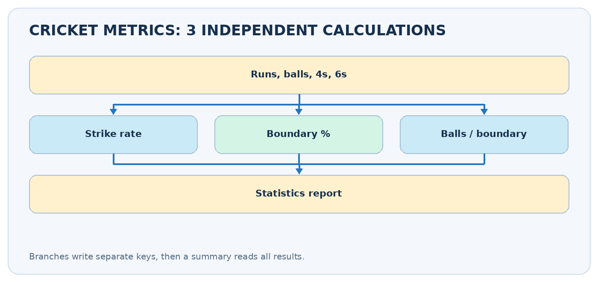
Cricket statistics branches and join
from typing import TypedDict, NotRequired
from langgraph.graph import StateGraph, START, END
class CricketState(TypedDict):
runs: int
balls: int
fours: int
sixes: int
strike_rate: NotRequired[float]
boundary_pct: NotRequired[float]
balls_per_boundary: NotRequired[float]
report: NotRequired[str]
def strike_rate(state: CricketState) -> dict:
return {"strike_rate": round(100 * state["runs"] / state["balls"], 2)}
def boundary_pct(state: CricketState) -> dict:
boundary_runs = 4 * state["fours"] + 6 * state["sixes"]
return {"boundary_pct": round(100 * boundary_runs / state["runs"], 2)}
def balls_per_boundary(state: CricketState) -> dict:
boundaries = state["fours"] + state["sixes"]
return {"balls_per_boundary": round(state["balls"] / boundaries, 2)}
def summarize(state: CricketState) -> dict:
return {"report": (
f"SR={state['strike_rate']}; boundaries={state['boundary_pct']}%; "
f"balls/boundary={state['balls_per_boundary']}"
)}
builder = StateGraph(CricketState)
builder.add_node("strike_rate", strike_rate)
builder.add_node("boundary_pct", boundary_pct)
builder.add_node("balls_per_boundary", balls_per_boundary)
builder.add_node("summarize", summarize)
for branch in ("strike_rate", "boundary_pct", "balls_per_boundary"):
builder.add_edge(START, branch)
# A list of sources defines an explicit join before summarize.
builder.add_edge(["strike_rate", "boundary_pct", "balls_per_boundary"], "summarize")
builder.add_edge("summarize", END)
app = builder.compile()
print(app.invoke({"runs": 80, "balls": 50, "fours": 8, "sixes": 3})["report"])
Safety of arithmetic: if balls=0, runs=0, or fours+sixes=0, these divisions fail. Validate inputs at the start in a production app. Doing numeric checks in Python is more reliable than asking an LLM to guess statistics.

4. Why partial state updates are essential
Imagine three branches receive the same state. If each returns a full copied dictionary, they may all write the same keys such as runs, balls, or status during one superstep. With the default last-value update channel, multiple writes to one key in one superstep can raise InvalidUpdateError.
# Good: each branch owns its own result key.
def metric_a(state):
return {"metric_a": 10}
def metric_b(state):
return {"metric_b": 20}
# Bad design for a parallel fan-out: both branches write 'shared_result'
# without a reducer.
def branch_a(state):
return {"shared_result": "A"}
def branch_b(state):
return {"shared_result": "B"}
Keep a simple rule: one branch, one owned key, unless you have deliberately defined merge semantics with a reducer.

5. Reducers: merging multiple updates into one list
Sometimes several branches should contribute to the same collection. Example: three essay graders each return a score and short feedback. Define a reducer for shared list keys.
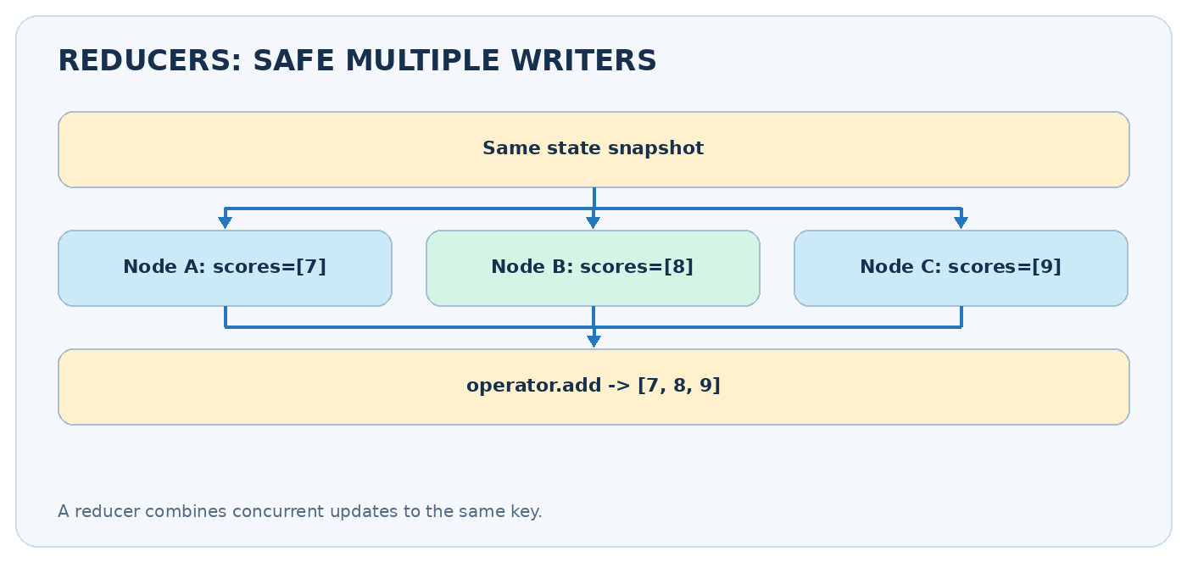
Reducer: each branch contributes a small list
from typing import Annotated, TypedDict
import operator
class ReviewState(TypedDict):
essay: str
scores: Annotated[list[int], operator.add]
feedback: Annotated[list[str], operator.add]
def clarity(state: ReviewState) -> dict:
return {"scores": [8], "feedback": ["Clear structure"]}
def depth(state: ReviewState) -> dict:
return {"scores": [7], "feedback": ["Needs more evidence"]}
def language(state: ReviewState) -> dict:
return {"scores": [9], "feedback": ["Good grammar"]}
If the existing scores are [8] and a new update is [7], operator.add combines them into [8, 7]. Always return a list to a list reducer ([8], not 8). For parallel work, do not depend on list order matching node order: attach a reviewer name to each item, or use separate keys.

6. LLM-based application: evaluate a UPSC essay
A richer parallel workflow can ask three models, or the same model with three different prompts, to evaluate:
- Clarity: Is the argument easy to follow?
- Depth: Does it use relevant evidence and counterarguments?
- Language: Is expression precise and grammatical?
Each reviewer should return score and feedback. Instead of asking the model to write arbitrary text, define a Pydantic structured output schema:
from pydantic import BaseModel, Field
class Grade(BaseModel):
score: int = Field(ge=0, le=10)
feedback: str = Field(min_length=1)
# With a configured compatible ChatOpenAI model:
# grade_model = model.with_structured_output(Grade)
# grade: Grade = grade_model.invoke("Evaluate clarity of: ...")
The aggregation node can calculate the average from the three numeric scores and combine feedback into one report. Structured output helps parsing, but it does not guarantee the scores are fair or objective. Evaluate graders on representative examples and use human checks for consequential assessments.

7. Explicit joins and synchronization
A common mistake is wiring each branch directly to the same summarizer without considering whether it should wait for all required results. For a fixed set of parallel paths, express the join directly:
builder.add_edge(["clarity", "depth", "language"], "final_report")
This means the final report depends on completion of those branches. If different paths execute conditionally or have different lengths, plan how you will synchronize them; do not assume the first arriving result means the whole job is finished.

8. Cost, performance, and debugging
- Latency: roughly bounded by the slowest parallel branch (plus other overhead); measure it rather than assuming a 3x speedup.
- Token usage: three independent LLM calls still consume tokens three times. Parallelism optimizes waiting time, not necessarily cost.
- Rate limits: concurrent model calls may hit provider concurrency limits.
- Side effects: two branches should not update the same external file or record without an explicit coordination strategy.
- Observability: stream updates to see branch outputs without waiting for the final summary.
for update in app.stream(
{"runs": 80, "balls": 50, "fours": 8, "sixes": 3},
stream_mode="updates",
):
print(update)

9. Sequential vs parallel vs conditional
Question | Sequential | Parallel | Conditional
How many branches? | One ordered path | Several independent paths | Usually one chosen path
When do steps run? | After prior step | Together in one phase | According to a decision
Main risk | High latency | Conflicting state updates | Wrong route
Typical use | Draft -> edit | Three independent reviewers | Refund vs tech support

10. Practice and revision
Exercise: extend the cricket graph with a fourth branch computing dot-ball percentage, then add a final warning if denominators are zero. Next, modify the essay review graph to keep named score records instead of relying on arbitrary append order.
- ☐ I can draw fan-out and fan-in.
- ☐ I know why parallel branches must return partial updates.
- ☐ I can explain Annotated[list[int], operator.add].
- ☐ I can write an explicit multi-node join.
- ☐ I know how structured outputs support multi-reviewer pipelines.
- ☐ I understand latency improvements do not imply lower API cost.
Next lesson: Conditional Workflows — choose a path based on the current state.

Further reading
- LangGraph Graph API / reducers: https://docs.langchain.com/oss/python/langgraph/graph-api
- CampusX tutorial code: https://github.com/campusx-official/langgraph-tutorials

